**WHEN IT LOADS PROPERLY ON A PHONE IT LOOKS LIKE THIS:**

** **

** **

**WHEN IT DOESN’T LOAD PROPERLY, IT LOOKS LIKE THIS:**

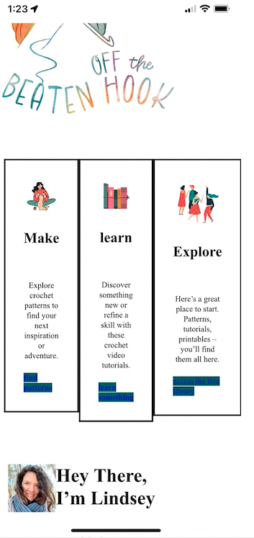 

**EITHER WAY, THE PORTFOLIO BLOCK NEVER LOADS PROPERLY. HERE ARE THE TWO WAYS IT LOADS:**

** **